**Syracuse University**

**Graduate Portfolio Milestone**

Master of Science Applied Data Science

**Prepared By**

ThulasiRam RuppaKrishnan

SUID: 460746269

<https://www.linkedin.com/in/thulasiram-ruppa-krishnan-8744a45b/>

<https://github.com/truppakr/AppliedDataScience>

Table of Contents

Introduction 5

Learning Path 6

Learning Objective 7

Learning Outcome 8

Introduction to Data Science (IST 687) 8

Course Description 8

Knowledge Gained 8

Assignments and Projects 8

Data Analysis and Decision Making (MBC 638) 9

Course Description 9

Knowledge Gained 9

Assignments and Projects 9

Data Analytics (IST 707) 10

Course Description 10

Knowledge Gained 10

Assignments and Projects 10

Business Analytics (SCM 651) 11

Course Description 11

Knowledge Gained 11

Assignments and Projects 11

Financial Analytics (FIN 654) 12

Course Description 12

Knowledge Gained 12

Assignments and Projects 12

Text Mining (IST 736) 13

Course Description 13

Knowledge Gained 13

Assignments and Projects 13

Big Data Analytics (IST 718) 14

Course Description 14

Knowledge Gained 14

Assignments and Projects 14

Scripting for Data Analysis (IST 652) 15

Course Description 15

Knowledge Gained 15

Assignments and Projects 15

Introduction to Information Security (IST 623) 16

Course Description 16

Knowledge Gained 16

Assignments and Projects 16

Natural Language Processing (IST 664) 17

Course Description 17

Knowledge Gained 17

Assignments and Projects 17

Information Visualization (IST 719) 18

Course Description 18

Knowledge Gained 18

Assignments and Projects 18

Advanced Database Administration Concepts and Database Management (IST 769) 19

Course Description 19

Knowledge Gained 19

Assignments and Projects 19

Key Projects 20

IST 687 - NYS-Motor-Vehicle-Crashes Fatal accident Prediction 20

Analysis 20

XG Boost Model Outcome 20

Importance Matrix 21

MBC 638- Reduce Cycle Time to Report RTE Numbers 21

IST 707 - Craft Beer style Prediction and Brewery Analysis 22

Analysis 23

Model Outcome 23

Decision Tree Classification 24

Results 24

https://github.com/truppakr/AppliedDataScience/tree/master/03-IST707-DataAnalytics/Project 24

FIN654 - Financial Analytics on Coffee business 25

Descriptive Statistics 25

Volatility 26

Risk Assessment 26

IST 736 - Text Mining on TED Talks and Popularity Prediction 27

Clustering 27

Topic Distribution 27

Popularity prediction Outcome 28

IST 652 - Zillow home value Prediction 29

Initial Analysis 29

Correlation matrix 29

Model outcome 30

Top 3 counties that are profitable for 2018 investment 30

IST-664 Classification of Email Spam Corpora using NLP 31

Data Description 31

Word cloud Inference 31

Model Outcome 32

IST 719 - Information Visualization 33

Learning Highlights 34

Courses Completed 34

Results - Skills and Knowledge Gained 35

Technical Skills Acquired: 35

Domain Knowledge Gained: 35

Analytical Skills Gained: 35

Presentation Skills Gained: 35

# Introduction

Data science is an inter-disciplinary field that uses scientific methods, processes, algorithms and systems to extract knowledge and insights from many structured and unstructured data. Data science is related to data mining, deep learning and big data.

Data science is a "concept to unify statistics, data analysis, machine learning and their related methods" in order to "understand and analyze actual phenomena" with data. It uses techniques and theories drawn from many fields within the context of mathematics, statistics, computer science, and information science. Turing award winner Jim Gray imagined data science as a "fourth paradigm" of science (empirical, theoretical, computational and now data-driven) and asserted that "everything about science is changing because of the impact of information technology" and the data deluge

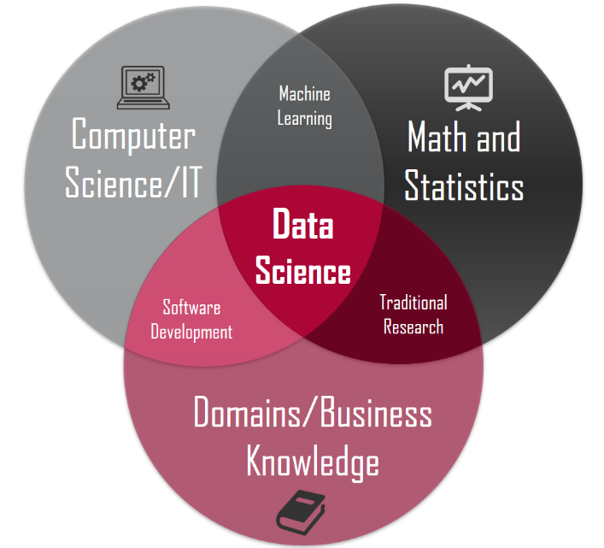

**MS in Applied Data Science @ Syracuse University**

Developed by the School of Information Studies in conjunction with the Martin J. Whitman School of Management, the MS in Applied Data Science program draws insights from both the field of information studies and the field of management to help students effectively apply analytical concepts to gain insight from data.

# Learning Path

This program offered an extensive learning curve in each semester and helped me to gain all the required knowledge to shine in the field of Data Science and a short description of each semester and the knowledge gained is depicted in the below infographics

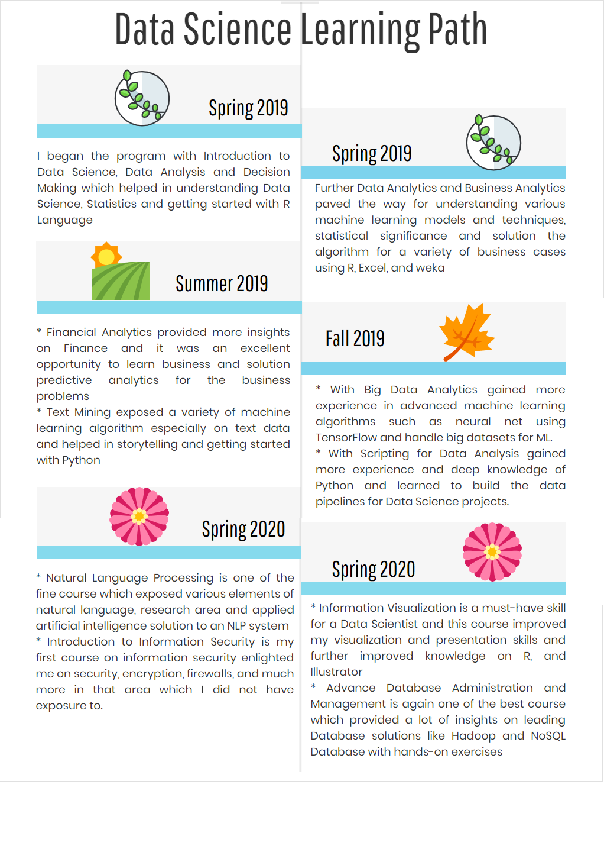

# Learning Objective

The following are the learning objectives of the Syracuse Master of Applied Data Science Program.

* Describe a broad overview of the major practice areas in data science.
* Collect and organize data.
* Identify patterns in data via visualization, statistical analysis, and data mining.
* Develop alternative strategies based on the data.
* Develop a plan of action to implement the business decisions derived from the analyses.
* Demonstrate communication skills regarding data and its analysis for relevant professionals in their organization.
* Synthesize the ethical dimensions of data science practice.

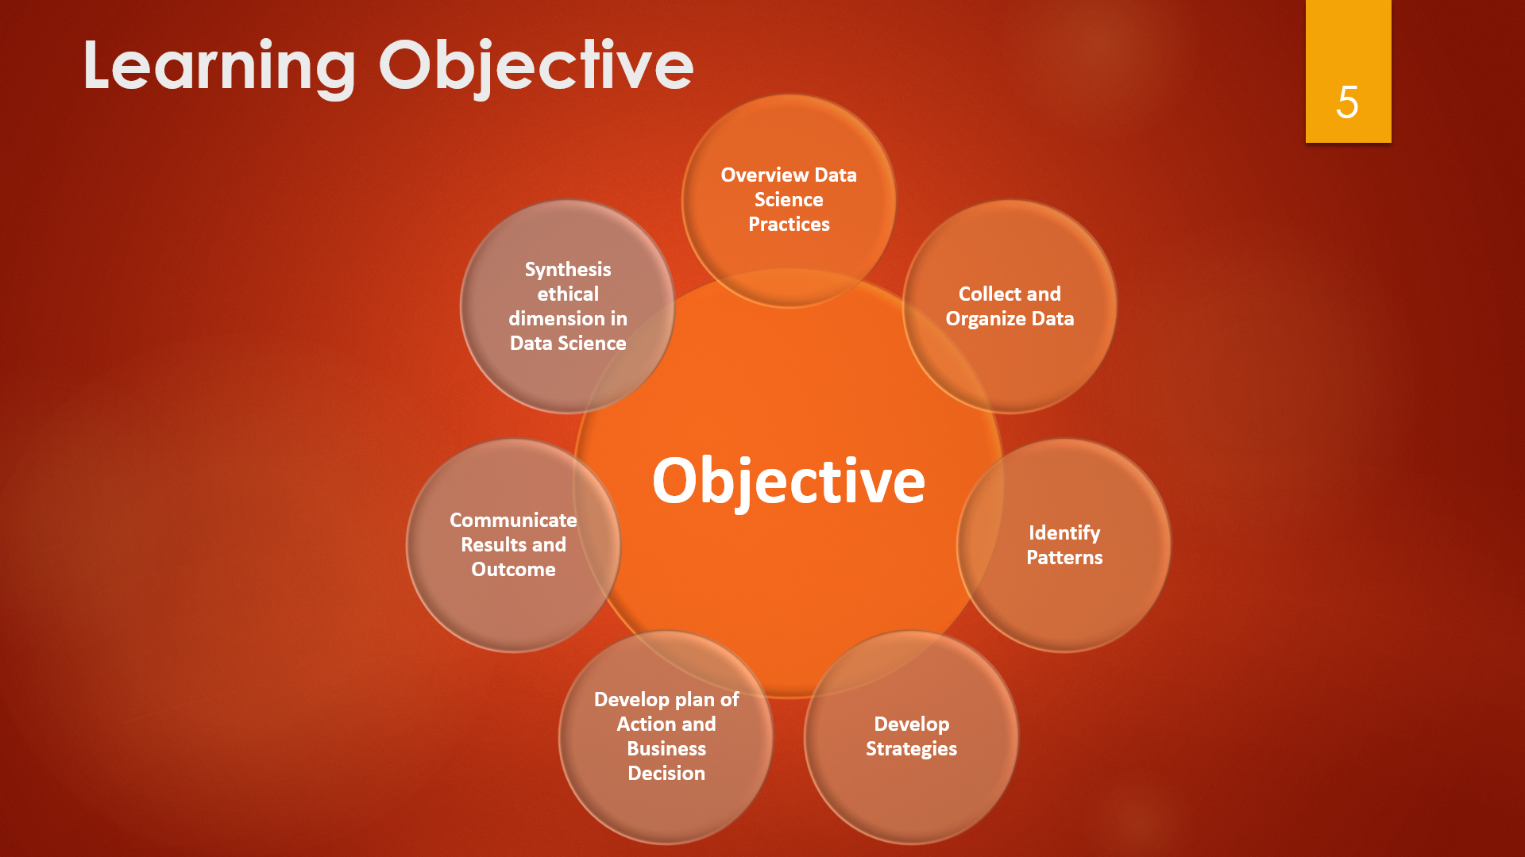

# Learning Outcome

## Introduction to Data Science (IST 687)

### Course Description

The course introduces applied examples of data collection, processing, transformation, management, and analysis to provide hands-on introduction to data science experience. Helps to explore key concepts related to data science, including applied statistics, information visualization, text mining and machine learning. “R”, the open source statistical analysis and visualization system, is used throughout the course.

### Knowledge Gained

* Essential concepts and characteristics of data.
* Scripting/code development for data management using R and R-Studio.
* Principles and practices in data screening, cleaning, and linking.
* Communication of results to decision makers
* Identify a problem and the data needed for addressing the problem.
* Perform basic computational scripting using R and other optional tools.
* Transform data through processing, linking, aggregation, summarization, and searching.
* Organize and manage data at various stages of a project lifecycle.
* Determine appropriate techniques for analyzing data

### Assignments and Projects

<https://github.com/truppakr/AppliedDataScience/tree/master/01-IST687-IntroductiontoDataScience>

## Data Analysis and Decision Making (MBC 638)

### Course Description

This course familiarized the assumptions underlying various statistical techniques and in identifying their appropriateness in a variety of situations. This course helps to perform statistical analysis and interpret results in a meaningful and relate results of such analyses to become an information-based decision maker.

### Knowledge Gained

* Understand the value of data collection and analysis in acquiring knowledge and making decisions in today’s business environment.
* Identify and apply the appropriate statistical technique for a given set of conditions in order to answer a question.

### Assignments and Projects

[https://github.com/truppakr/AppliedDataScience/tree/master/02-MBC638-DataAnalysisandDecisionMaking](https://github.com/truppakr/AppliedDataScience/tree/master/02-MBC638-DataAnalysisandDecisionMaking/Project)

## Data Analytics (IST 707)

### Course Description

Introduction to data mining techniques, familiarity with real-world applications, challenges involved in these applications, and future directions of the field. Hands-on experience with open-source software packages.

This course introduced data mining methods for extracting knowledge from data. The principles and theories of data mining methods are discussed. Hands-on experience using state-of-the-art software to develop data mining solutions to scientific and business problems.

Understanding of data and formulate data mining tasks in order to solve problems using the data. The course included the key tasks of data mining, including data preparation, concept description, association rule mining, classification, clustering, evaluation and analysis and develop skills that can be applied to business, science or other organizational problems.

### Knowledge Gained

* Document, analyze, and translate data mining needs into technical designs and solutions.
* Apply data mining concepts, algorithms, and evaluation methods to real-world problems.
* Employ data storytelling and dive into the data, find useful patterns, and articulate what patterns have been found, how they are found, and why they are valuable and trustworthy.

### Assignments and Projects

<https://github.com/truppakr/AppliedDataScience/tree/master/03-IST707-DataAnalytics>

## Business Analytics (SCM 651)

### Course Description

This course introduced and provided hands on experience in developing a portfolio of skills in business analytics.

### Knowledge Gained

* Data collection: using tools to collect and organize data (e.g., Google Analytics)
* Data analysis: identify patterns in the data via visualization, statistical analysis, and data mining
* Strategy and decisions: develop alternative strategies based on the data
* Implementation: develop a plan of action to implement the business decisions

### Assignments and Projects

<https://github.com/truppakr/AppliedDataScience/tree/master/04-SCM651-BusinessAnalytics>

## Financial Analytics (FIN 654)

### Course Description

This course is designed for analysts interested in pursuing a career in financial services with an emphasis on business analytics. Financial services traditionally include banking, insurance, securities markets, and regulators. However, financial services are also found in organizational treasuries, departments of finance, CFO offices, investor relations, and any project where budgets, valuations, road maps, planning, and process efficiency require future projections of cash flows, growth rates, risk, and return.

### Knowledge Gained

Methods and tools useful in decision-making in the financial industry which includes the following

* Macroeconomic event studies
* Analysis of term structures
* Equity data analysis
* Style analysis
* Credit risk
* Extreme value analytics
* Trading analytics
* Volatility measurement
* Portfolio management
* Enterprise risk management.

### Assignments and Projects

<https://github.com/truppakr/AppliedDataScience/tree/master/05-FIN654-FinancialAnalytics>

## Text Mining (IST 736)

### Course Description

This course exposed the power of large amounts of text data and computational methods to find patterns in large text corpora. This course introduced the concepts and methods of text mining technologies rooted from machine learning, natural language processing, and statistics along with the applications of text mining technologies in

(1) information organization and access,

(2) business intelligence,

(3) social behavior analysis, and

(4) digital humanities.

### Knowledge Gained

* Describe basic concepts and methods in text mining, for example document representation, information extraction, text classification and clustering, and topic modeling;
* Use benchmark corpora, commercial and open-source text analysis and visualization tools to explore interesting patterns;
* Understand conceptually the mechanism of advanced text mining algorithms for information extraction, text classification and clustering, opinion mining, and their applications in real-world problems; and
* Choose appropriate technologies for specific text analysis tasks and evaluate the benefit and challenges of the chosen technical solution

### Assignments and Projects

<https://github.com/truppakr/AppliedDataScience/tree/master/06-IST736-TextMining>

## Big Data Analytics (IST 718)

### Course Description

This course introduced analytical processing tools and techniques for information professionals and to develop knowledge on portfolio of resources, demonstrations, recipes, and examples of various analytical techniques. Familiarity with command-line interfaces, basic quantitative skills, including statistics, as well as programming skills with languages such as R or Python. Most of the course used Python, Spark, and TensorFlow.

### Knowledge Gained

* Obtain data and explain data structures and data elements.
* Scrub data by applying scripting methods, to include debugging, for data manipulation in Python, R or other languages.
* Explore data by analyzing using qualitative techniques including descriptive statistics, summarization, and visualizations.
* Model relationships between data using the appropriate analytical methodologies matched to the information and the needs of clients and users.
* Interpret the data, model, analysis, and findings. Communicate the results in a meaningful way. Select an applicable analytical methodology for real problems in areas such as business, science, and engineering.

### Assignments and Projects

<https://github.com/truppakr/AppliedDataScience/tree/master/07-IST718-BigDataAnalytics>

## Scripting for Data Analysis (IST 652)

### Course Description

Scripting for the data science pipeline. Acquiring, accessing, and transforming data in the forms of structured, semi structured, and unstructured data.

### Knowledge Gained

* Write scripts to access and amass data from fields in structured data, access fields in semi structured data, and define and find patterns of data in unstructured data;
* Prepare and transform data to produce data summaries, lists, and networks;
* Analyze and solve data access problems for the three types of data and to find and deploy appropriate software packages that can be integrated into the problem solution; and
* Frame real-world data questions and show how they can be answered from data

### Assignments and Projects

<https://github.com/truppakr/AppliedDataScience/tree/master/08-IST652-ScriptingforDataAnalysis>

## Introduction to Information Security (IST 623)

### Course Description

This course taught fundamental elements in information security and introduce the key areas of security challenges, countermeasures, and applications. The course focused on a comprehensive understanding of information security rather than an in-depth analysis of an area.

Topics include security properties, vulnerabilities, cryptography, public key infrastructure (PKI), security policies, authentication, access control, security protocols, network security, cyber-attacks, and security management with research opportunities and hands-on experiences in information security.

### Knowledge Gained

* The fundamental elements in information security.
* In-depth security knowledge and skills in the research areas
* Hands-on ability to analyze security properties using various security services and tools. Collaboration with other colleagues to perform team projects in information security.
* On a specific area of information security, extending the contents learned from this course.

### Assignments and Projects

<https://github.com/truppakr/AppliedDataScience/tree/master/09-IST623-IntroductiontoInformationSecurity>

## Natural Language Processing (IST 664)

### Course Description

This course is designed to develop an understanding of how natural language processing (NLP) can process written text and produce a linguistic analysis that can be used in other applications.

This goal is achieved through:

* Readings, lectures, and class discussions of the multiple levels of linguistic analysis required for a computer to accept natural language input, interpret it, and carry out an application.
* Lab exercises and assignments in using some of the computational techniques required to perform these levels of natural language processing of text.
* Studies of real­world applications that incorporate substantive NLP modules.

The course primarily covers the techniques of NLP in the levels of linguistic analysis, going through tokenization, word level semantics, parts of speech tagging, syntax, semantics, and on up to the discourse level. It also includes the use of the NLP techniques, such as information retrieval, question answering, sentiment analysis, summarization, and dialogue systems, in applications.

### Knowledge Gained

* Demonstrate the levels of linguistic analysis, the computational techniques used to understand text at each level, and what the challenges are for those techniques.
* Process text through the language levels using the resources of the Natural Language Toolkit (NLTK) and some rudimentary use of the programming language Python.
* Describe how NLP is used in many types of real­world applications.

### Assignments and Projects

<https://github.com/truppakr/AppliedDataScience/tree/master/10-IST664-NaturalLanguageProcessing>

## Information Visualization (IST 719)

### Course Description

A broad introduction to data visualization for information professionals. This course has developed a portfolio of resources, demonstrations, recipes, and examples of various data visualization techniques.

Introduction to skills and techniques related to information visualization, through the R programming language and Adobe Illustrator. These skills include using data cleaning techniques, controlling the R graphics environment, developing custom plots, visually exploring data, using design concepts to visually communicate the story in the data, and discussing issues related to the ethics of data visualization. Conceptual themes are also presented alongside technical aspects of data visualization.

### Knowledge Gained

1. Use R to do basic data cleaning and preparation on a wide range of datasets

* Use functions to summarize and compare fields
* Find missing values
* Use subsets or filter data
* Retype data into correct format

2. Identify stories in datasets through exploration

* Use R to create appropriate rough plots to identify distributions and relationships in the data
* Use data subsetting and filtering to home in on questions of interest

3. Create rich visual artifacts that communicate data stories

* Identify the optimal type of visualization to minimize viewer cognitive overload and maximize image interpretability
* Enhance viewer cognition through context cues
* Use basic design principles to enhance viewer receptivity and convey meaning
* Use Adobe Illustrator to combine R data visualizations, design elements, and context cues into a single artifact

### Assignments and Projects

<https://github.com/truppakr/AppliedDataScience/tree/master/11-IST719-InformationVisualization>

## Advanced Database Administration Concepts and Database Management (IST 769)

### Course Description

An analysis of relational and nonrelational databases and their corresponding database management system architectures. Learn to build complex database objects to support a variety of needs from both the big data and traditional perspectives. Data systems performance, scalability, and security

This course provided a tour of relational, document, key-value, columnar, and streaming database systems through the lens of the CAP theorem.

* Explore the strengths and weaknesses of various database systems in the relational, Hadoop, and NoSQL spaces.
* Experience these systems first-hand as to gain an understanding of how they can be used to address complex, big data challenges.

### Knowledge Gained

* Understand advanced issues with the relational database model, such as transactions, performance, and security, as to understand the need for other database models.
* Explain the CAP theorem and describe how any given database system’s architecture fits within the CAP context.
* Compare different database models such as document, key-value, column-family, streaming, and relational.
* Identify the most suitable database systems for a specific application’s data storage requirements. Evaluate relational, Hadoop, and NoSQL database tooling as to understand their underlying similarities and necessary differences.

### Assignments and Projects

<https://github.com/truppakr/AppliedDataScience/tree/master/12-IST769-AdvancedDatabaseAdministrationConceptsAndDatabaseManagement/Assignments>

# Key Projects

## IST 687 - NYS-Motor-Vehicle-Crashes Fatal accident Prediction

The aim of this project is to predict if the accident will end up in fatal or no fatal based on the characteristic observed at the time of accident.

NYS-Motor-Vehicle-Crashes data is used to develop a model using XG boost and the model outcome turned out to be 98.34% accurate in predicting if the accident involved is fatal or non-fatal.

Interesting findings are observed in the importance matrix and it is found that variables which are contributing the fatal is aggressive driving, Age, occurrence of bleeding and Injury location.

### Analysis

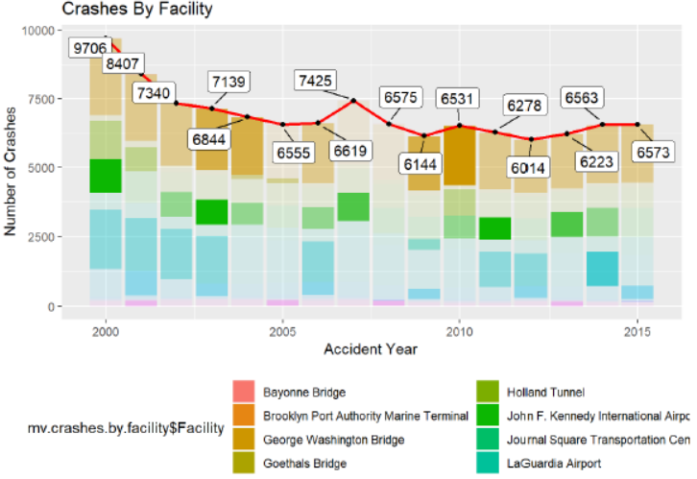 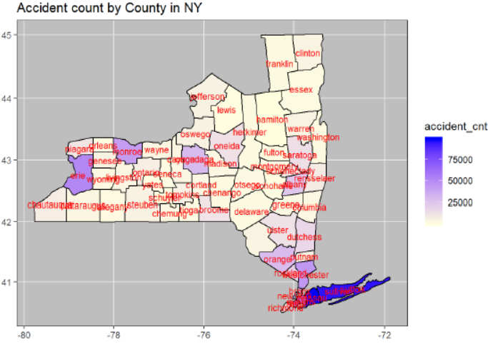

### XG Boost Model Outcome

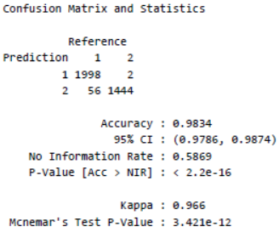

### Importance Matrix

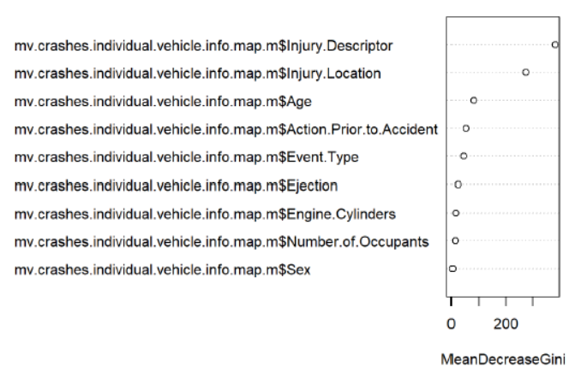

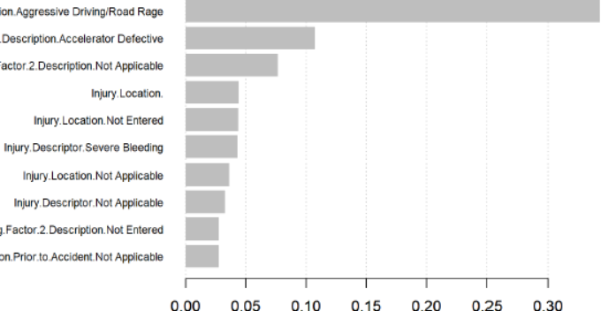

More details about this project is available in the below link

<https://github.com/truppakr/AppliedDataScience/tree/master/01-IST687-IntroductiontoDataScience/Project>

## MBC 638- Reduce Cycle Time to Report RTE Numbers

The aim of this project is to apply DMAIC tool and improve the existing process. For this purpose, I choose a process in my workplace which is inefficient. It is observed that the after executing this project, the overall performance of the process is improved and observed potential savings in the business.

The high-level tools and techniques used in this project are laid out in the below picture.

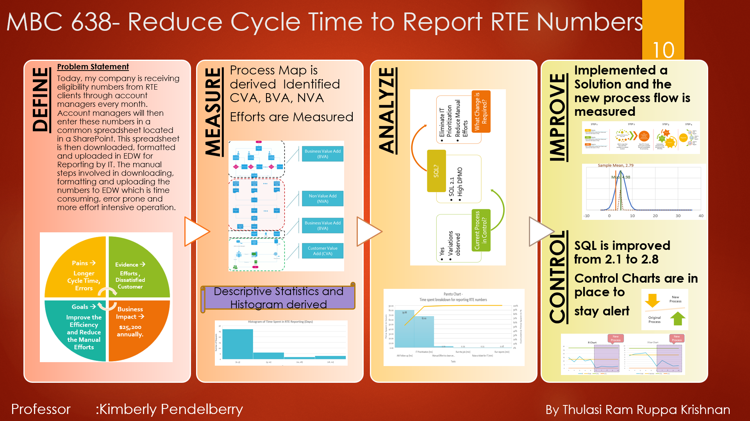

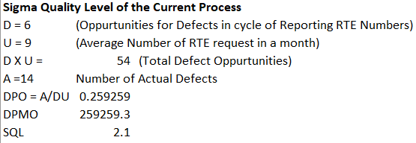

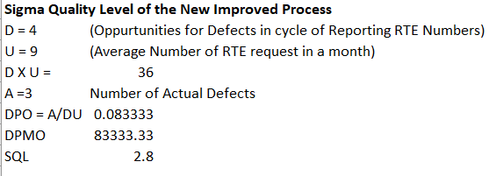

More details about this project is available in the below link

<https://github.com/truppakr/AppliedDataScience/tree/master/02-MBC638-DataAnalysisandDecisionMaking/Project>

## IST 707 - Craft Beer style Prediction and Brewery Analysis

The aim of this project is to predict the beer style based on the properties observed in the beer and perform data analytics on the properties of the beer.

Association rule mining is also performed on all the variables to see if there are an association between two or more variables in the dataset.

### Analysis

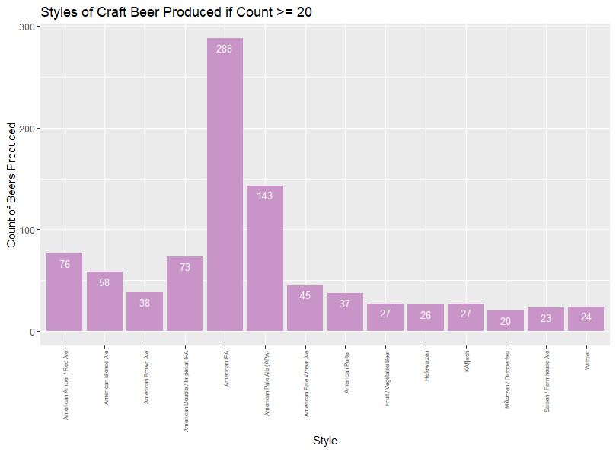 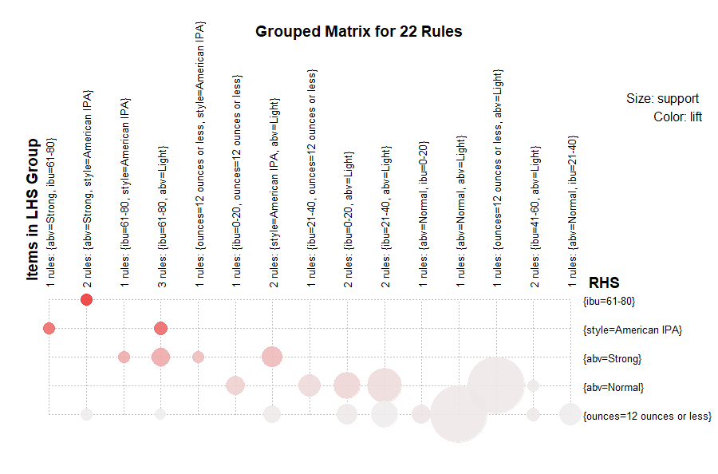

### Model Outcome

Model Accuracy

---------------------------------------------

Naïve Bayes 🡪 56.11%

SVM 🡪 53.4%

KNN 🡪 50.83%

Random Forest 🡪 56.44%

### Decision Tree Classification

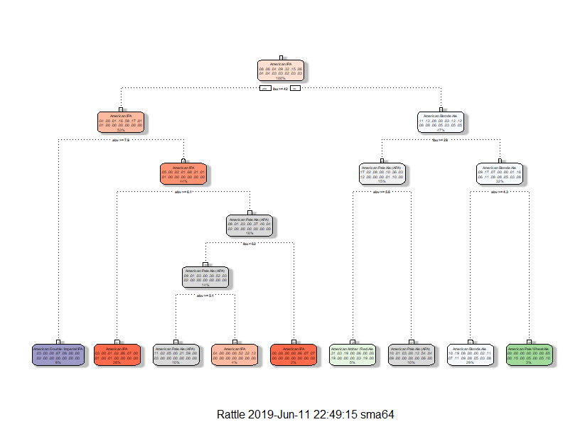

### Results

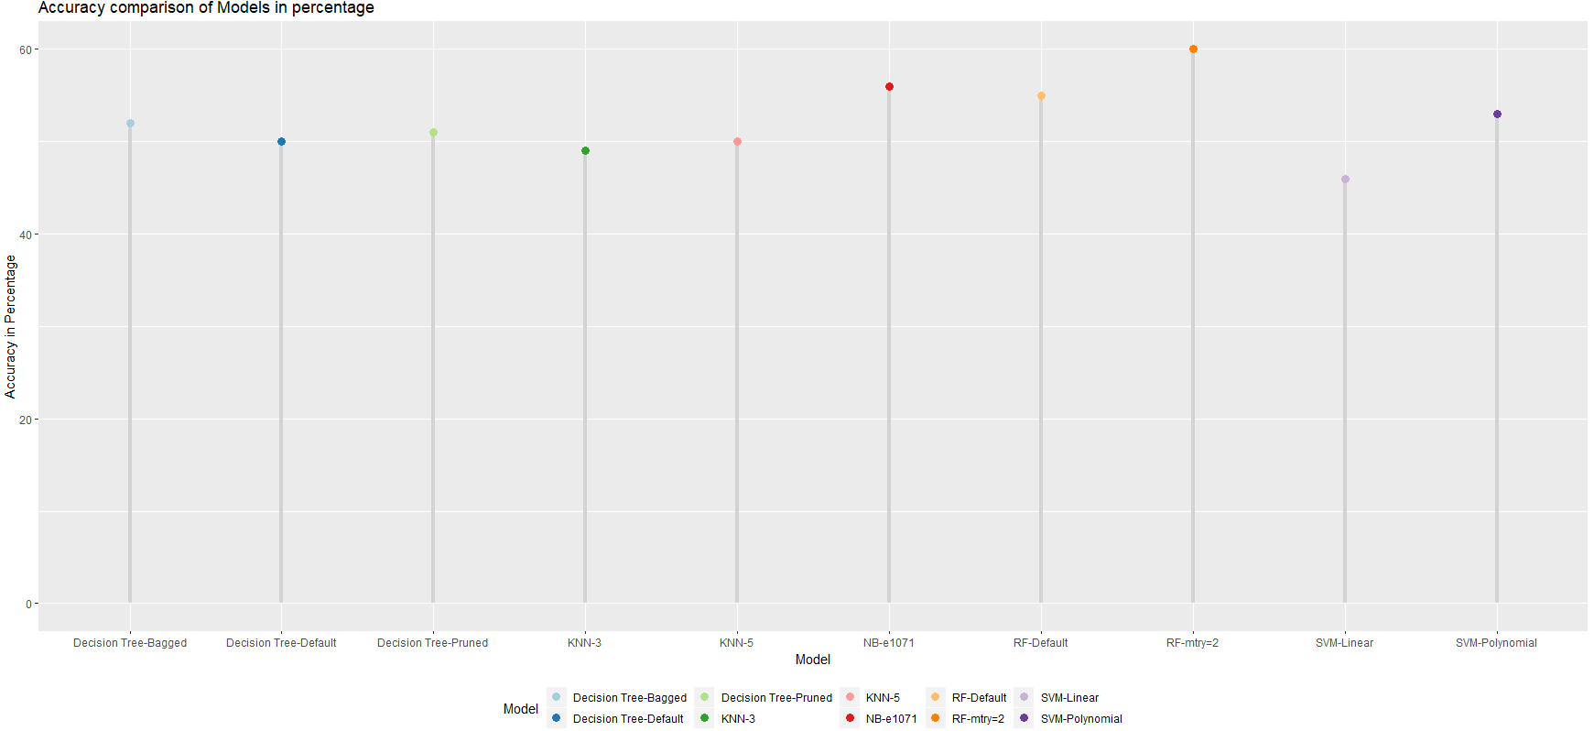

More details about this project is available in the below link

## <https://github.com/truppakr/AppliedDataScience/tree/master/03-IST707-DataAnalytics/Project>

## FIN654 - Financial Analytics on Coffee business

The aim of this project is to analyze the coffee business in USA and in international markets to answer key business questions regarding company’s move to acquire international markets and its risk

### Descriptive Statistics

Coffee and Tea markets

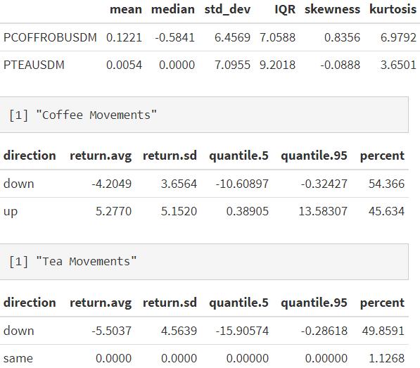

Currency markets

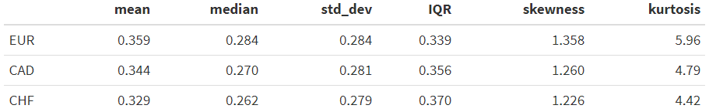

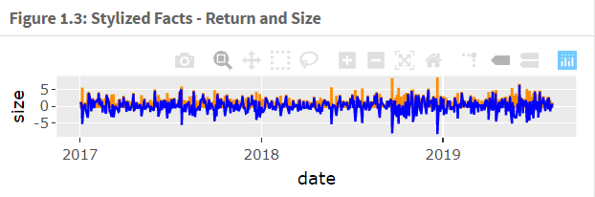

### Volatility

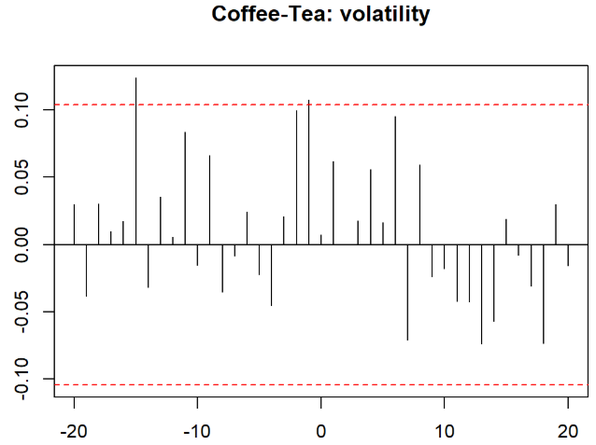 

### Risk Assessment

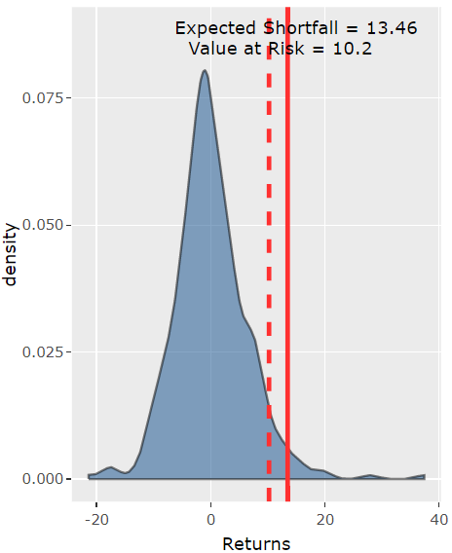

How much capital we would need? Determine various measures of risk in the tail of distribution. Determine the risk capital we might need.

**Expected shortfall is $13.46 M VaR is $10.2 M The coffee company already had $10 M for managing receivables and needs and additional $3.46 M as a risk capital to handle extreme events**

More details about this project is available in the below link

<https://github.com/truppakr/AppliedDataScience/tree/master/05-FIN654-FinancialAnalytics/Project>

## IST 736 - Text Mining on TED Talks and Popularity Prediction

The aim of the project is to perform text mining on TED Talks and predict popularity of the TED Talk

### Clustering

The following clusters are observed in the dataset base on the K means algorithm on the text generated from TED Talks

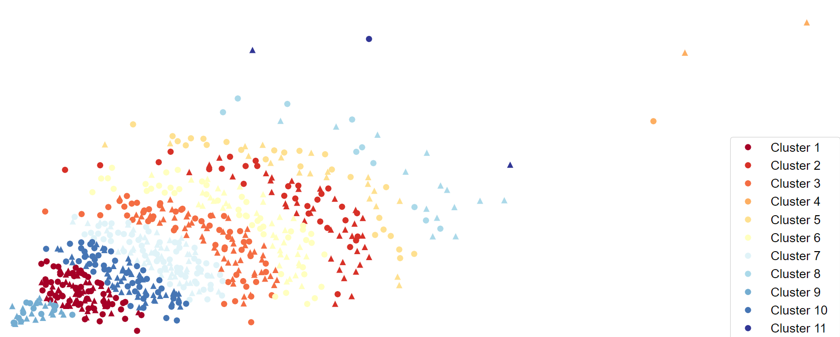

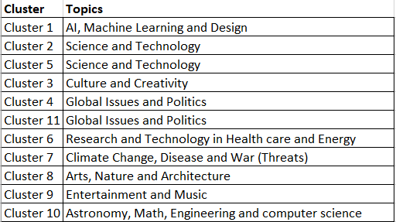

### Topic Distribution

Based on the LDA analysis the topics are identified and the top words in each topic are given below

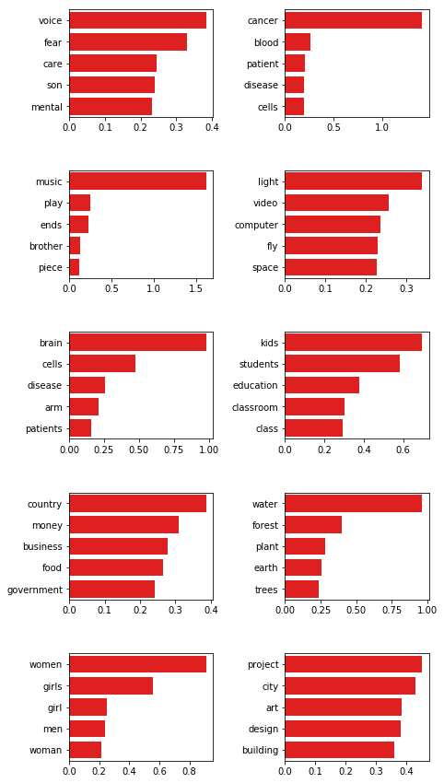

### Popularity prediction Outcome

The popularity prediction outcome and the correlation matrix are as follows

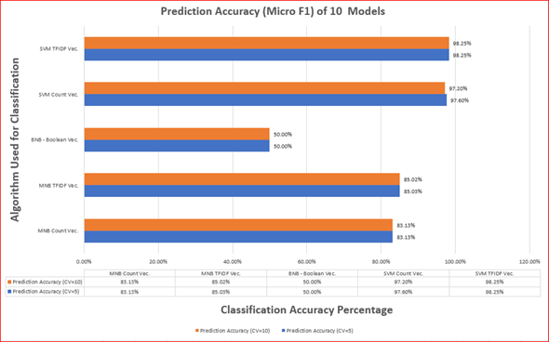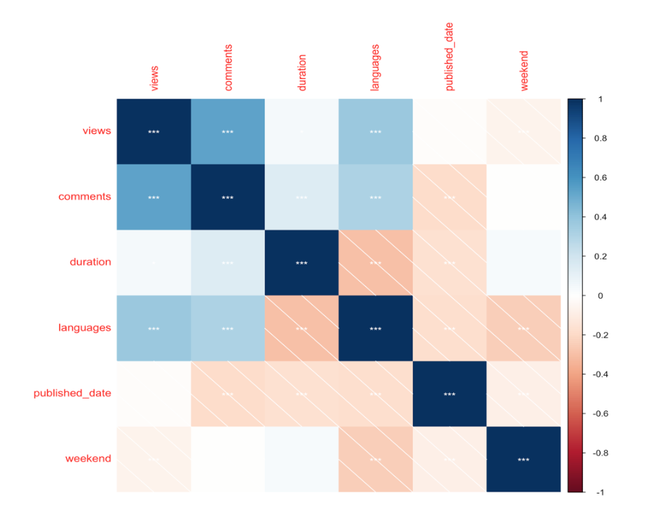

More details about this project is available in the below link

<https://github.com/truppakr/AppliedDataScience/tree/master/06-IST736-TextMining/Project>

## IST 652 - Zillow home value Prediction

### Initial Analysis

Initial analysis on a sample of 4 counties and their home value index over the given period are shown here

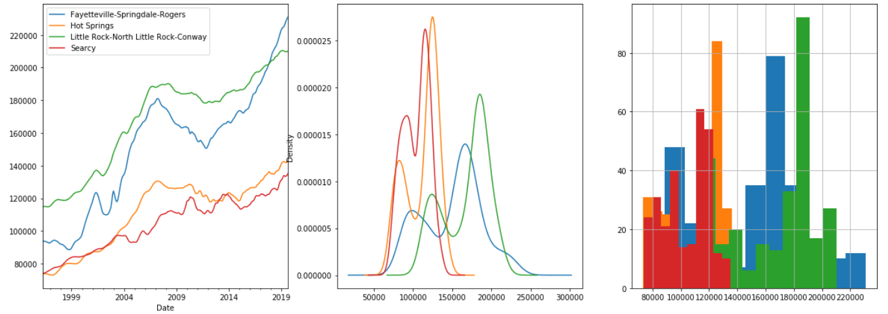 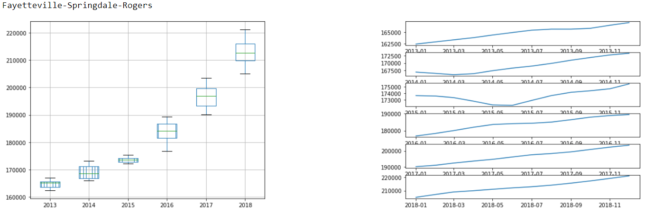

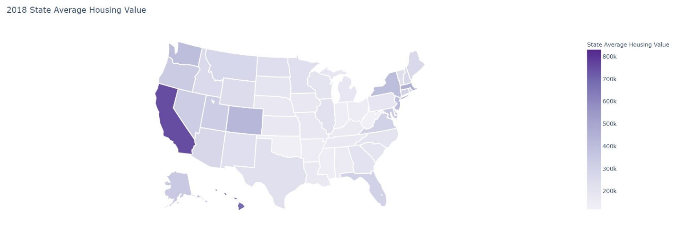

### Correlation matrix

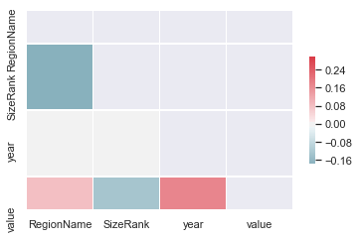

### Model outcome

OLS regression is performed to predict the ZHVI and the model outcome is 98% accurate

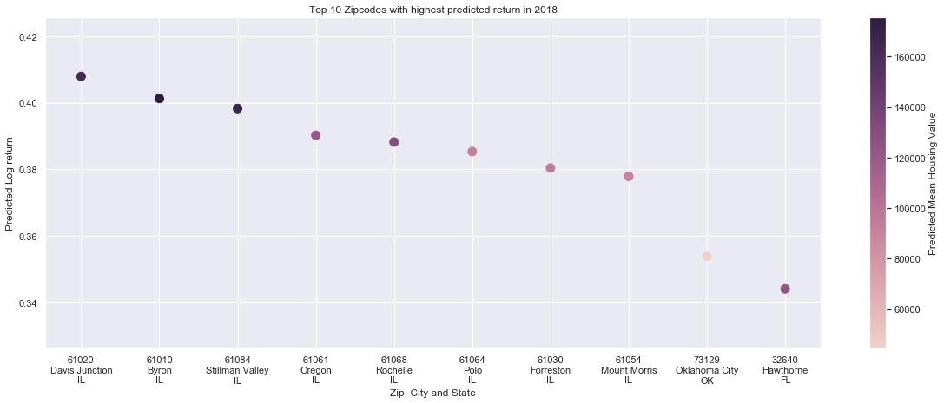

### Top 3 counties that are profitable for 2018 investment

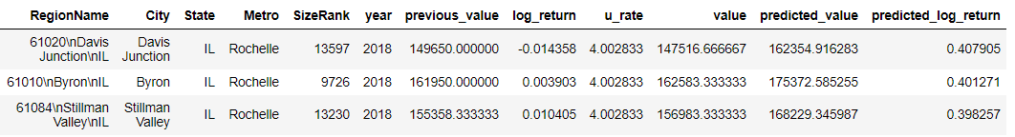

More details about this project is available in the below link

<https://github.com/truppakr/AppliedDataScience/tree/master/08-IST652-ScriptingforDataAnalysis/Project>

## IST-664 Classification of Email Spam Corpora using NLP

The aim of this project is to create models to identify Ham and Spam emails using NLP techniques

### Data Description

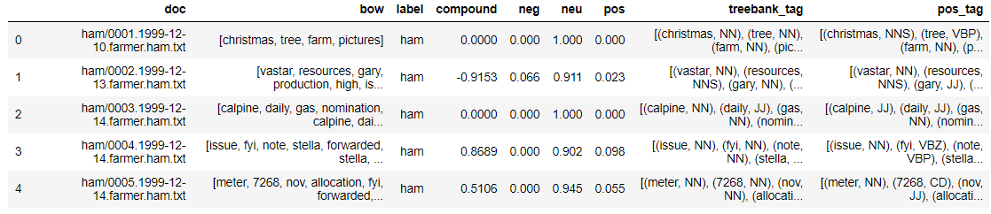

### Word cloud Inference

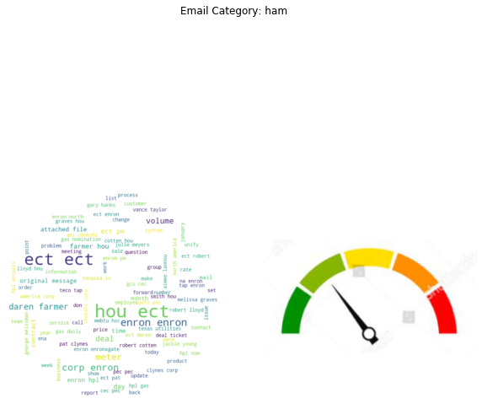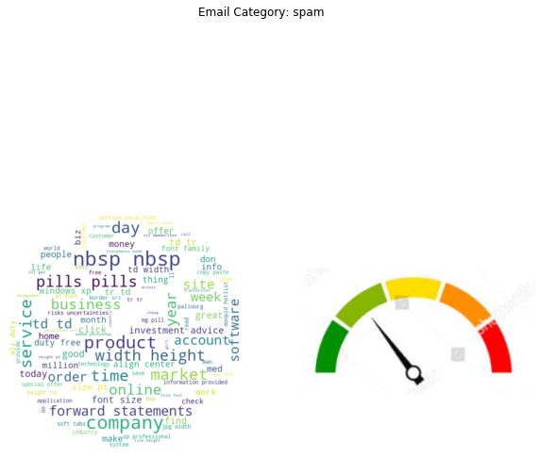

Ham SPAM

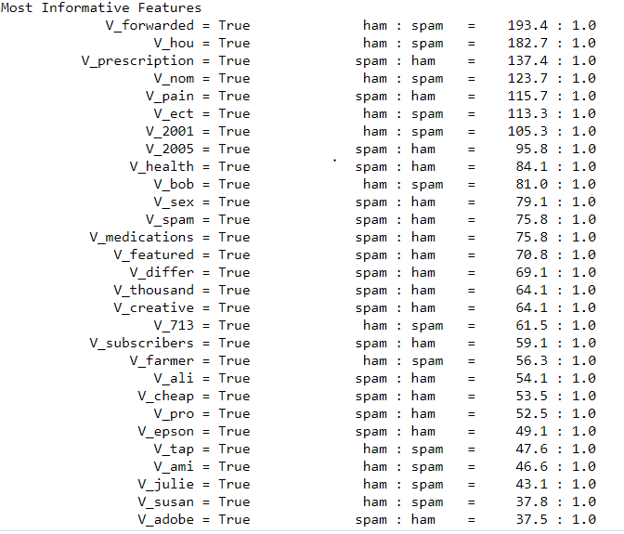

### Model Outcome

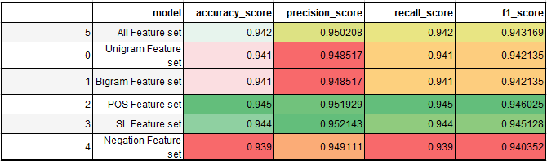

More details about this project is available in the below link

<https://github.com/truppakr/AppliedDataScience/tree/master/10-IST664-NaturalLanguageProcessing/Project>

## IST 719 - Information Visualization

The aim of this project is to convey the story visually using USA health data

Interesting facts about America's health are observed and as follows and these metrics can be grouped into 3 clusters

**Metrics in Cluster 1** shows high **Positive correlation** between themselves are Drug overdose deaths, Firearm fatalities, Alcohol impaired driving deaths, Motor vehicle deaths, Single parent households, Homeowners, Injury deaths, Non-Hispanic white, Average violent crimes, Unemployed, Workers who drive alone and Uninsured

**Metrics in Cluster 2** that shows high **Positive correlation** between themselves are Asians, Percent with access to exercise opportunities, Median household income, Life expectancy

**Metrics in Cluster 3** that shows high correlation between themselves are Percent smokers, Percent adults with obesity, Percent physically inactive, Percent adults with diabetes, Injury death rate, Percent fair or poor health, Percent children in poverty, Percent limited access to healthy foods, Firearm fatalities rate, Teen birth rate, Motor vehicle mortality rate

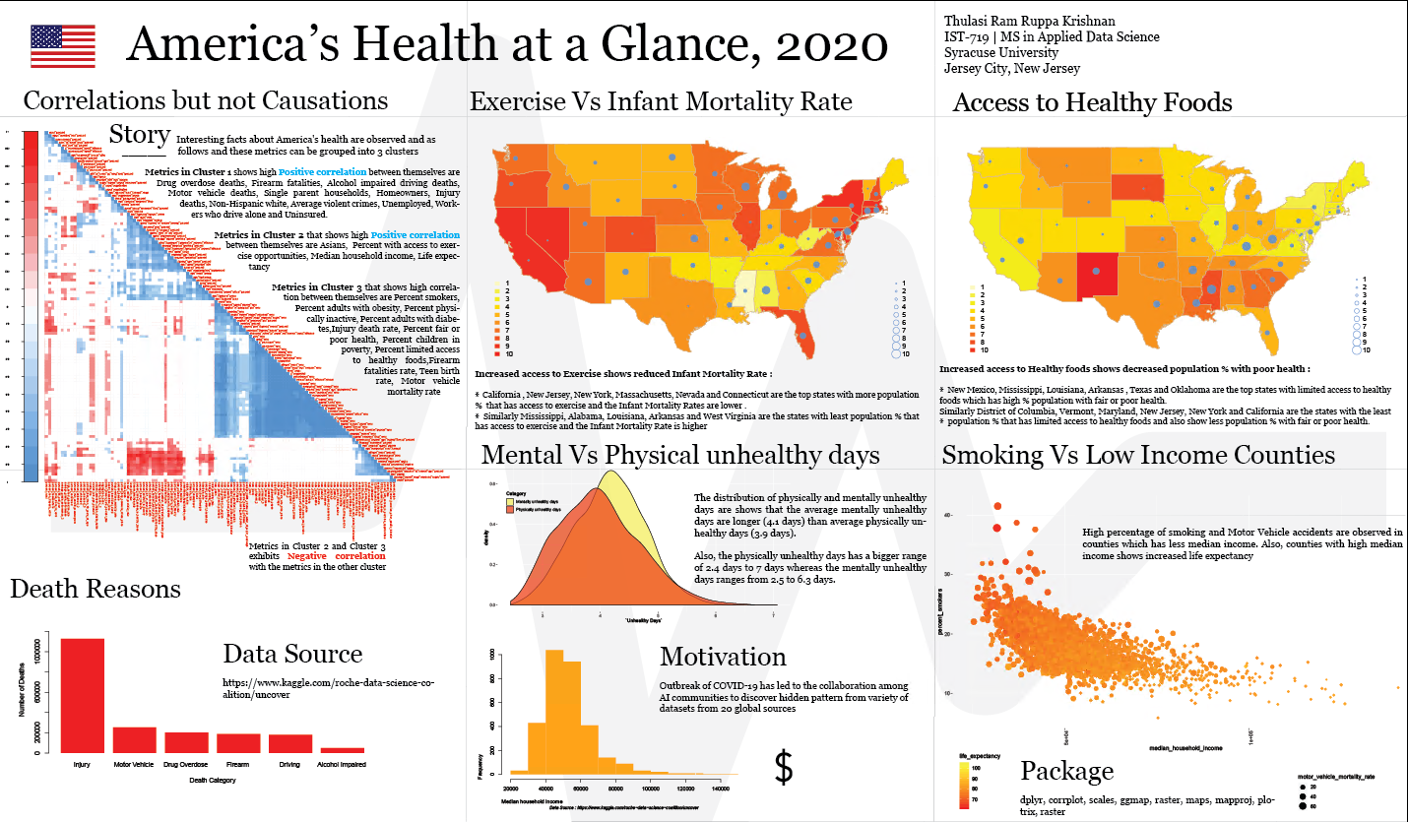

The latest version of the poster and the pdf format of the above poster is available in the below location

<https://github.com/truppakr/AppliedDataScience/tree/master/11-IST719-InformationVisualization/Poster>

# Learning Highlights

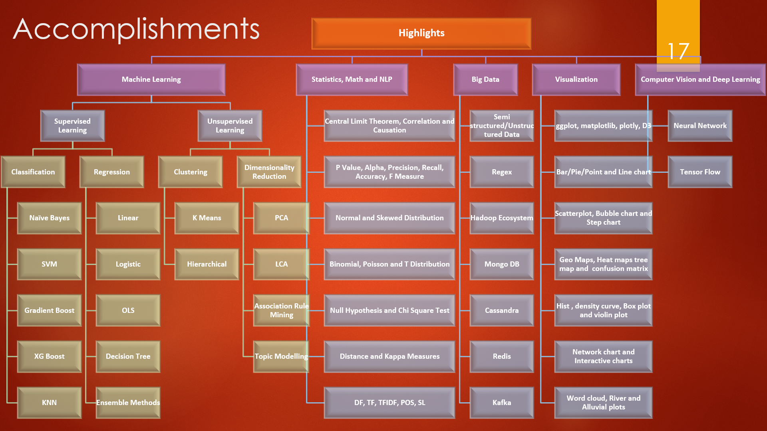

# Courses Completed

Completed course with the timeline and grades are available in the below table

|  |  |  |  |  |  |
| --- | --- | --- | --- | --- | --- |
| **Dept. Prefix & No.** | **Course Title** | **Semester** | **Credit Hours** | **Grade** | **Instructor** |
| IST 687 - M402 | Introduction to Data Science | Spring 2019 | 3 | A+ | John Santerre |
| MBC 638 - M400 | Data Analysis and Decision Making | Spring 2019 | 3 | A- | Kimberly Pendelberry |
| IST 707 - M405 | Data Analytics | Spring 2019 | 3 | A+ | Ami Gates |
| SCM 651 - M426 | Business Analytics | Spring 2019 | 3 | A- | Raghavshyam Ramamurthy |
| FIN 654 - M401 | Financial Analytics | Summer 2019 | 3 | A+ | William Foote |
| IST 736 - M400 | Text Mining | Summer 2019 | 3 | A+ | Ami Gates |
| IST 718 - M402 | Big Data Analytics | Fall 2019 | 3 | A+ | Jillian Lando |
| IST 652 - M402 | Scripting for Data Analysis | Fall 2019 | 3 | A+ | Lefteris Anastasopoulos |
| IST 623 - M400 | Introduction to Information Security | Spring 2020 | 3 | A+ | Joon Park |
| IST 664 - M401 | Natural Language Processing | Spring 2020 | 3 | A+ | Michael Larche |
| IST 719 - M402 | Information Visualization | Spring 2020 | 3 | In Progress | Gary Krudys |
| IST 769 - M401 | Advanced Database Administration Concepts and Database Management | Spring 2020 | 3 | In Progress | Gregory Block |

# Results - Skills and Knowledge Gained

## Technical Skills Acquired:

**Programming** R, Python**,** AdvancedSQL.

**Big Data Tools** Hadoop, HDFS, Hive, pig, HBase, Impala, Mongo DB, Cassandra, Redis, Kafka

**Data science tools** Weka, TensorFlow, Scikitlearn, NLTK

**Visualization tools** Plotly**,** D3, Adobe Illustrator

**Databases** SQL Server

**Other Tools:** GitHub, Kleopatra, Excel, DMIAC, Docker, Collab, Jupyter Notebooks

**Communities** Kaggle

## Domain Knowledge Gained:

* Finance Analytics
* Business Analytics
* Information Security

## Analytical Skills Gained:

* Data/Bigdata Analytics
* Data Mining
* Text Mining
* Decision Making

## Presentation Skills Gained:

* Story Telling
* Effective Communication
* Visualization